A Greedy Algorithm for Aligning DNA Sequences
Zheng Zhang, Scott Schwartz, Lukas Wagner, Webb Miller
Journal of Computational Biology, Vol.7, No. 1/2, Pp.203-214, 2000
Abstract
A new alignment algorithm can be much faster than traditional dynamic programming approaches and produce an alignment that is guaranteed to be theoretically optimal.
- An X-drop Algorithm
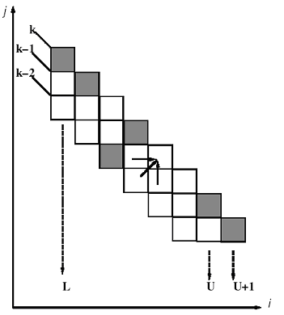
I. 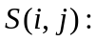 the score of the best alignment

II. antidiagonal k: the set of all points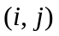 such that 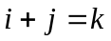

III. variable X: uesr-specified, if we discover that 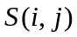< T – X, ,then we set to -∞

- Steps of the dynamic programming X-drop algorithm :

- initialize T, S(0,0), T`
- set k← k+1
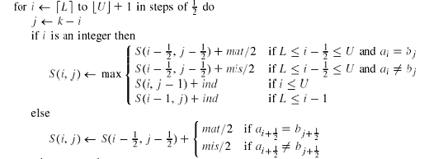3. if S(i,j) < T-X then S(i,j) ← -∞
- prune L & U according to the values of i
- repeat steps 2 - 4 until L > U+1
2. A Greedy Algorithm

I. Suppose the alignment scoring parameters satisfy 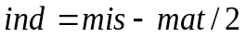.Then any alignment of 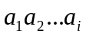 and 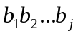 with d differences has score
II. Suppose 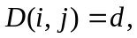define
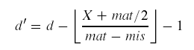
and
then,
for all 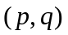 < 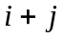
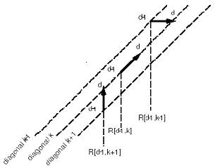

- Steps of the greedy Algorithm:

- initialize , d, L, U
- use a loop to find the first position that 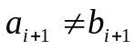, set
R(0,0)←
- set d←d+1 and set d`
- for k ← L-1 to U+1 do
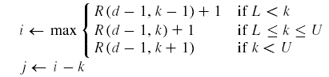
then

check whether 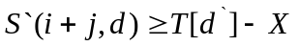or not, if the condition is true, find the first position that 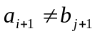.
Set R(d,k) ← , else set R(d,k) ← -∞
- prune L & U according to the values of R(d,k)
- repeat step 3 – 5 until L > U+2

- Determining an optimal alignment

Created by : Hung-Wei Huang
Date : Dec. 13, 2002

